Student Information System

for Exam



Walchand College of Engineering , Sangli

(Department of Information Technology)

Prepared By-

Ankita Zade (2020BTEIT00012)

Anmol Shelar (2020BTEIT00013)

Contents

1. Introduction 3
   1. Purpose 3
   2. Scope 4
   3. Overview 4
2. General Description 5
3. Functional Requirements 5
4. Interface Requirements 6
5. Performance Requirements 9
6. Design Constraints 9
7. Non-Functional Attributes 9
8. Appendices 11

# Introduction

This document will propose all features and procedures to develop the system. Specially containing details about objectives, scope limitation process model, primary requirements, team development, schedule, and finally monitoring and reporting mechanisms. possible project risks, project

On-line Exam System is very useful for Educational Institute to prepare an exam, save the time that will take to check the paper and prepare mark sheets. It will help the Institute to testing of students and develop their skills. But the disadvantages for this system, it takes a lot of times when you prepare the exam at the first time for usage. And we are needs number of computers with the same number of students.

The effective use of 'On-line Exam System', any Educational Institute or training centers can be use it to develop their strategy for putting the exams, and for getting better results in less time.

The Student Information System (SIS) is a System that manages the records of student and examination part. A Student Information System (SIS) is designed to help colleges for management of dental student. Extensive information is available at your fingertips through this System. Block allocation, subject management, scheduling exam, result and related issues are made simple and easy. There are custom search capabilities to aid in finding student information and working on student records. This can make the system easier to navigate and to use maximizing the effectiveness Etime and other resources. SIS allows the keeping of personnel data in a form that can be easily accessed and analysed in a consistent way.

## Purpose

The project is about to handle all the information of the student regarding examination. Also it manages resources which were managed and handled by manpower previously. The main purpose of the project is to integrate distinct sections of the organization into consistent manner so that complex functions can be handled smoothly by any technical or non-technical persons.

The project aims at the following matters:

* Assistance in decision-making.
* To manage information of student, faculty and courses.

The main purpose of the Admin Module is to introduce new things and configure important aspects. For e.g. only admin is authorized to introduce quota, board, subject, category, etc. and only admin is allowed to configure exam and set fees structure. So the master screens for all these are visible to only admin role. This is done by the Admin Module. It also can create the users and Physical and Logical Locations. Thus the main purpose of the Admin Module is to managing the dynamic working of the system

## Scope

1. The scope of the project includes the following:
2. ♣Any college can use this system as it is not client centric.
3. ♣All admission and examination related work for the student can be done using this
4. system.
5. ♣Deliver Electr
6. The scope of the project includes the following:
7. ♣Any college can use this system as it is not client centric.
8. ♣All admission and examination related work for the student can be done using this
9. system.
10. ♣Deliver Electr
11. The scope of the project includes the following:
12. ♣Any college can use this system as it is not client centric.
13. ♣All admission and examination related work for the student can be done using this
14. system.
15. ♣Deliver Electr
16. The scope of the project includes the following:
17. ♣Any college can use this system as it is not client centric.
18. ♣All admission and examination related work for the student can be done using this
19. system.
20. ♣Deliver Electr

Scope of this project is very broad compared to manually taken exams. They are:-

* This app can be used in educational institutions as well as in corporate world.
* Can be used anywhere any time as it is a web based application (user location doesn’t matter).
* No restriction that examiner has to be present when the candidate takes the test.
* No manual work of preparing and storing the result information.
* Less time consumption, as the result is calculated immediately after the test and displayed to the student/candidate.
* For students/candidates, it saves time of going to far away centers to give exams.

1.3) Overview

OES is an on-line examination system. It is accessible via the Internet, 24 hours a day, 7 days a week. The objective of this app is to reach and connect candidate and examiner in remote communities and conduct exams in a virtual environment online. This app will only allow the registered users to enter the test module. The various stages in the app are as follows:-

* Login
* system Overview
* Test
* Result

**Login:**

This window offers the user two choices for logging into the system according to the preset privileges - Candidate login and Administrator login.

The candidate login will take the user to the user profile.

The Administrator Login will take the user to the administrator profile.

**System Overview:**

This window can only be accessed by the administrator. It allows the administrator to add and edit exams.

**Test:**

This window contains all the exams candidate can give. All these exams are organized according to the categories they fall in. The test window will be different for students and corporate employees.

**Result:**

This window displays the result of exams the candidate has just appeared. This data will be saved and displayed in the user profile. If the score is in top 10, the result will also be displayed in the rankings area of result window.

## 

## Product Functions**:**

The functions are divided according to the user types such as:

**Administrator:-**

The function of the administrator is to add/edit exams in the test module.

**Candidate:-**

The function of the student is to update his/her profile and give various exams.

# 2)General Description

## User Classes and Characteristics:

The various users of this app are classified into two types:-

* Administrator
* Candidate
* Student
* Corporate Employees

This app requires the user to have characteristics such as the user should be able to communicate and write in English and should have previous experience of giving an online exam. If not, the candidate should be instructed about the basics usage of the app by authorized personnel.

## User Documentation:

The product will include a user manual. The user manual will include product overview, complete configuration of the required software and hardware, technical details and contact information which will include email address

## Operating Environment:

This app is internet based so it will run in any operating system with internet access through a web browser.

# Functional Requirements

This section gives a functional requirement that applicable to the On-Line Examination system. There are three sub modules in this phase.

* Candidate module.
* Examiner module.
* Administrator module.
* Result rankings module
* Discussion Forum module

# Interface Requirements

### User Interfaces:

* **Registration Screen:**

Various fields available on this screen will be:

* + - -Login Name
    - -Email Id
    - -Password
* **Login Screen:**

Fields available on this screen are:

* + - -Login Name
    - -Password
* **Entering Questions:**

Various Fields are:

* -Questions
* -Options (4)
* -Correct Answer
* **Exam Details Screen:**

Various Fields are:

* + - * -Exam Name
      * -No. Of Questions
      * -Time Limit
      * -Passing Marks
* **Result Displaying Screen:**

Various Fields are:

* + - * -No. Of Correct Questions
      * -No. Of Incorrect Questions
      * -Total Marks
      * -Result(Pass/Fail)

### Use Case Diagram:

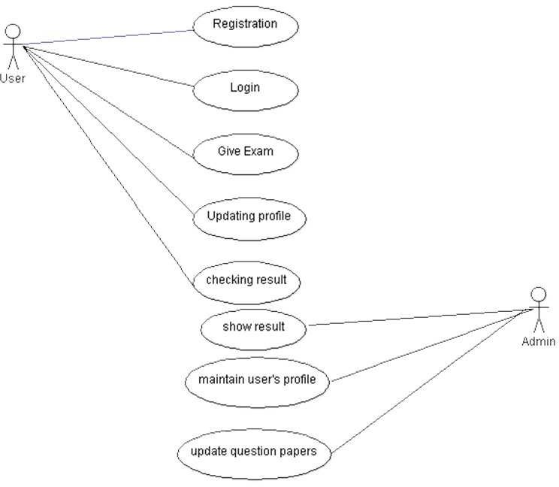

### Entity Relationship Diagram:

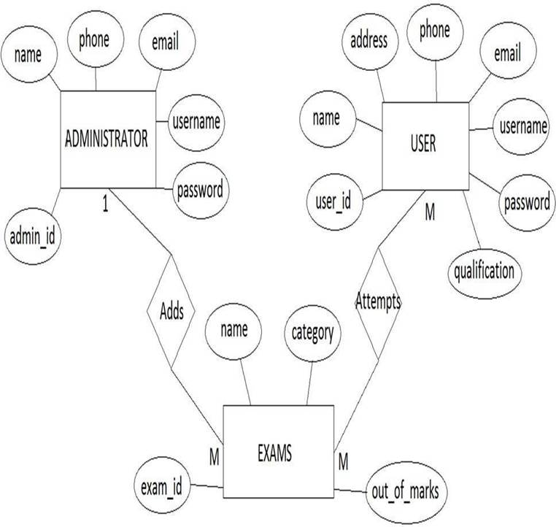

### Hardware Interfaces:

Screen resolution of at least 800X600 is required for proper and complete viewing of screens. Higher resolution will be accepted.

### Software Interfaces:

* Any windows based operating system.
* MySql Server Database
* Php and javascript

# Performance Requirements

The application should be able to operate on all major web-browsers with all of its fundamental functions . It should not slow-down the system even at peak hours without affecting the quality of service of the system.

Some Performance requirements identified is listed below:

* The database shall be able to accommodate a minimum of 1,000 records of Users.
* The software shall support use of multiple users at a time.
* There are no other specific performance requirements that will affect development.

# Design Constraints

### Technology Constraints:

Proposed web application will be implemented with Java for front end design purpose & For the database purpose, we can opt for Java DB/Oracle.

### Interface Constraints:

Since, this is a Web based application so it should work for NPTEL on major browsers like Internet explorer, Mozilla Firefox, Google Chrome, etc.

### Safety and Security Constraints:

Since, application is intended for the authenticated users only, so anonymous person should not be able to access and operate over the user data.

## 6.4) Design and Implementation Constraints:

The candidate is allowed to give the exams any number of times, until specified otherwise by the administrator while building the test. While giving the exam the candidate is given only a set amount of time and the remaining time should be displayed, after which the exam should close and display the result.

# Non-Functional Attributes

### Safety Requirements:

The database may get crashed at any certain time due to virus or operating system failure. Therefore, it is required to take the database backup.

### Security Requirements:

Some of the factors that are identified to protect the software from accidental or malicious access, use, modification below. Keep specific log or history data sets.

Assign certain functions to different modules.

### Software Quality Attributes:

The Quality of the System is maintained in such a way so that it can be very user friendly to all the users.

The software quality attributes are assumed as under:

* Accurate and hence reliable.
* Secured.
* Fast speed.
* Compatibility.

Reliability:

The application should be highly reliable and it should generate all the updated information in correct order.

Availability:

System will be available around the clock except for the time required for the back up of data.

Maintainability:

The installation and operation manual of examination management system will be provided to user.

Portability:

The application should be portable on any windows based system

# Assumptions and Dependencies:

Proper working of this app is dependent on the internet connectivity of the user’s computer

Assumptions and dependencies:

* It is assumed that the user has basic knowledge of the system (i.e. he/she is not a first time user) as any action by the user is considered valid during an examination.
* It is assumed that the data entered by the user while registering is true.
* It is assumed that the candidate does not cheat during the exam as there are no supervisors around to monitor.

9)Appendices:

Definition of online examination system:

Introduction:

Online Examination System is a software application which allows a particular company or institute to arrange, conduct and manage any objective examination via online.

Purpose:

The purpose of this application is to conduct and process various types of certificate/non-certificate exams at different centers across any country via online.

Features:

• Any institute or company can register their various types of certificate/non-certificate programs and

conduct an online examination for the same. Just register the programs, their fees (if paid) and the centers (where the exam will be conducted) in order to start the examination process.

• Questions and answers would be objective type and the format would be as per the company's choice.

• User can select the company, its program, exam schedule and pay fees online in order to give his exam at the selected center.

Advantages:

Today, most of the companies or institutes are conducting their exams online to be a part of this fastest growing world.

Online Examination System covers almost all type of problems faced by a company or institute while conducting online examinations.

User can give any available exam at any available center as per his/her choice. The results of the online exam will help a company or institute to list out the outstanding exam takers all over the country.